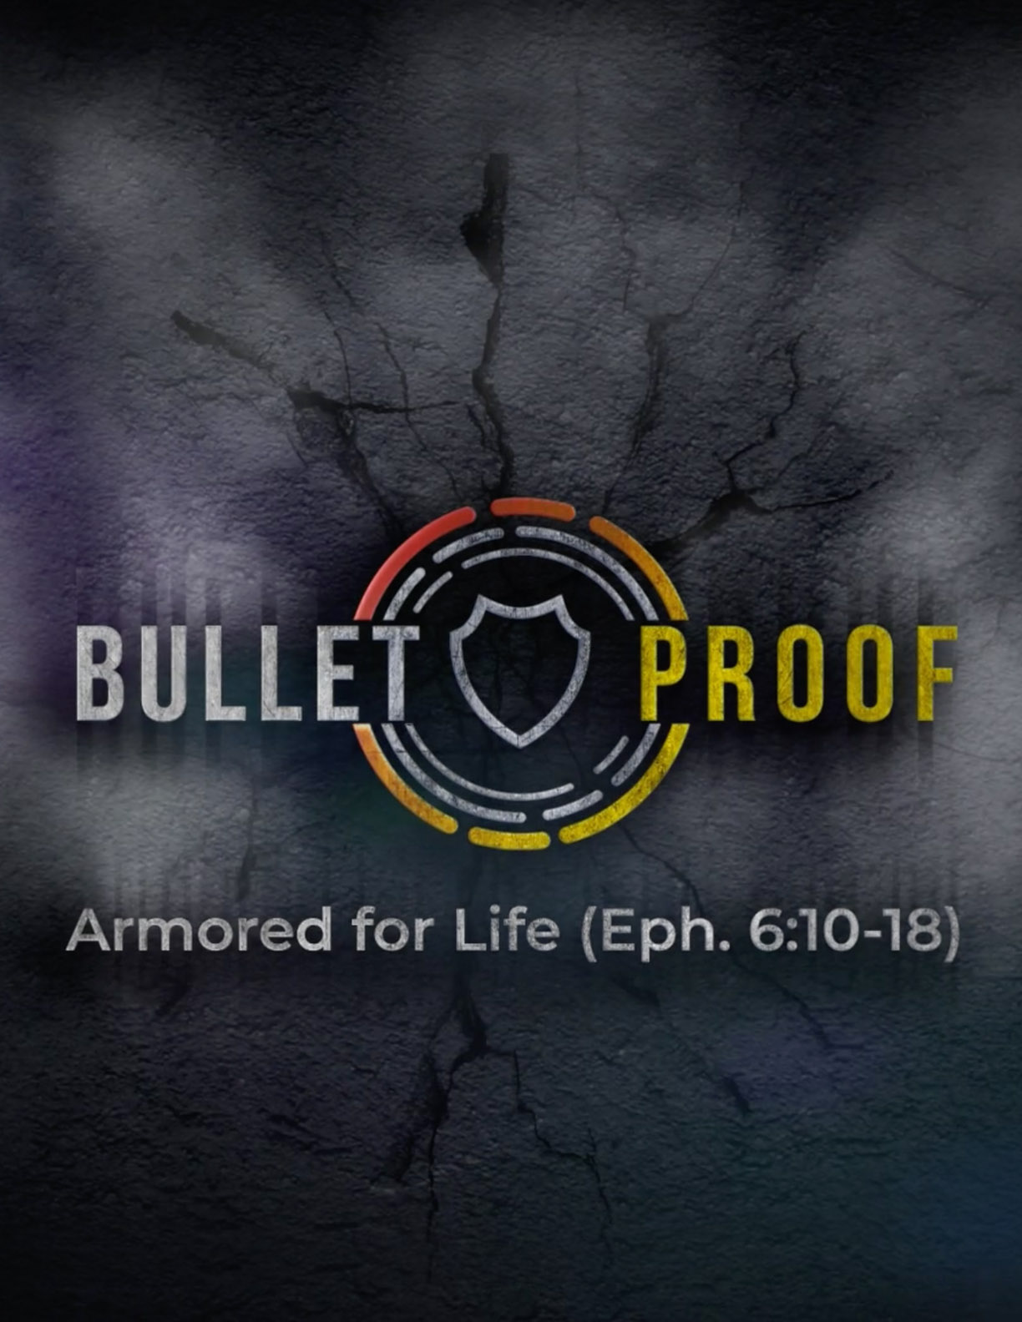

Bulletproof: Armored for Life
Big Idea of the Series: This 3-week series will cover the “Armor of God” in Ephesians 6:10-18. The point of these Scripture passages is to show us how to be bulletproof in a world (seen and unseen) where every weapon in their arsenal is fired against us. God provides the armor and the weapons for us to withstand and to fight back – making us bulletproof believers.

Week 1
Text: Ephesians 6:10-13
Topic: Spiritual Strength
Big Idea of the Message: God shows us how to fight, who to fight and where to fight, using His strength and great power.

Sermon Ideas and Talking Points:

- Ephesians chapter 6 tells us that our real war is “…against the rulers, against the powers, against the world forces of this darkness, against the spiritual forces of wickedness in the heavenly places.” (Ephesians 6:12) So, if our battle is against an enemy that we cannot see, how do we win against such a foe? First off, we must be aware, cautious, ready, and we must know what the Bible says about our enemies. Many people are overcome and defeated by circumstances and situations because they were not prepared for those to come. 1 Corinthians 16:13: “Be on the alert, stand firm in the faith, act like men, be strong.” Men and women of faith are to be like the brute warrior or strong man or a fighter – not in a physical sense but a spiritual one – to be spiritually tough! Stand firm and act like men (be brave) in faith in Christ Jesus.

- We see the need to put on the full armor of God so that we can stand against the devil and his schemes, traps, temptations and lies. Which means we will be knocked down by these without God’s armor to protect us. Not like wearing the helmet and you leave your chest exposed or you take up the shield with no sword. But we must be fully equipped, because the enemy looks for any weakness that they can manipulate. Example: In the original “Star Wars” movie, the Death Star was found to have a small but devastating weakness. The Rebellion exploited it and was able to cause the Death Star to explode from within. The enemy does the same with us.

They find and exploit our weaknesses; our temptations that lead us to sin and this will cause us to ultimately destroy ourselves. “God please grant me the ability to recognize devilish intentions, the armor to defend all attacks and the ability to trust despite past wrongdoings.” ― C. Wallace. How many times in life do we let our guard down and the enemy takes advantage of it?

- God provides His armor, but He does not put the armor on us. We must put it on ourselves. You must know your weaknesses and put on God’s strength, might and power to be able to stand firm against it. If you fly a fighter jet, you don’t want your plane to get shot down by enemy fighters, so you armor it. Planes that get hit in the engines don’t come back. If we don’t guard our hearts and minds in Christ Jesus (Phil. 4:7), then our engines will be taken out and we will be shot down. Here is a great Sunday School object lesson that gives an example of the Armor of God: https://www.youtube.com/watch?v=WR6LiMU_EtQ

- Never forget that you are vulnerable and need to constantly check and examine your fellowship with God. Are you bulletproof? Have you stood firm in the truth of God’s Word when the enemy comes at you? Did you know that the "Titanic" took 2 hours and 40 minutes to sink? Water filled one compartment after the next and slowly took the ship and the 1500 people who died to their grave. Satan, sin, and the world system do the same thing to us. Slowly, methodically, subtly they attempt to break us down (remove our armor) with temptation, anxiety, doubt, fear, worry, etc... Flooding one part of our life at a time until we drown. Jesus is the only lifeboat, the only One who will pull us out of the grave, give us freedom, and save us from our enemies and eternal death. He is our Armor!

Message LifePoint: We must be prepared to fight the good fight of faith constantly! True believers in Christ are in a continual battle with Satan, the world and our flesh. We gain strongholds when we put on the whole armor of God, knowing He has already won through the sacrifice and salvation brought to us by Jesus Christ upon the cross at Calvary. His Holy Spirit is our commander and we must use the full armor in its entirety to be victorious in spiritual combat.

Week 2
Text: Ephesians 6:14-15
Topic: Spiritual Armor
Big Idea of the Message: The first stages of putting on God’s armor and what each of them means to us.

Sermon Ideas and Talking Points:

- The Belt of Truth: “Stand firm then, with the belt of truth buckled around your waist…” We must surround ourselves with the truth of God’s Word. Biblical truth should always be at our core. It, just as a belt, must be around our center to keep us equalized. Deception, lies, misinformation, false doctrine and teachings are constantly bombarding us. We absolutely must put on truth for our own deliverance, as well as for the benefit of those to whom we witness the Gospel to. We must shine the light of truth into the darkness. Darkness will always flee from the light.

In the movie Rocky Balboa, Rocky’s character said this, “It ain’t about how hard you can hit. It’s about how hard you can get hit and keep moving forward.” Isa 11:5: “Righteousness shall be the belt of His waist, and faithfulness the belt of his loins.” This is our convictions agreeing with God’s truth. The belt is very vital because it holds the other armor in place and supports the sword. “The Gospel of Jesus Christ is the truth of God; unless this be known and conscientiously believed no man can enter the spiritual warfare with any advantage or prospect of success.” – Adam Clarke. This is truth of action, judgment, heart, speech and life.

If you have God’s truth consistently around your core, you will be so much harder to knock down. Boxers, MMA fighters, etc. are given belts around their waist when they become champions. Jesus told us in John 14:6: “I am the way, the TRUTH and the life, no one comes to the Father except through me.” He has made us champions and placed His victory belt of truth around us because of what He has done for us on the cross.
- The Breastplate of Righteousness: “…with the breastplate of righteousness in place…” A breastplate protected a warrior’s vital organs from blows that would often be fatal. Our spiritual breastplate is the righteousness of Christ, credited by God and received by faith, which guards our hearts against the fiery arrows of the enemy and secures our inmost being from their attacks. “It is referred to in the Scriptures as a ‘coat of mail’ (1 Samuel 17:5) …or as a “breast-plate.” We are told that Goliath’s coat of mail weighed five thousand shekels of brass, or nearly one hundred and sixty pounds…” (A. Barnes). Just as a breast plate covers our vital organs, spiritually the righteousness of Christ covers our heart from harm.
You can see a great visual demonstration of this here: https://www.youtube.com/watch?v=Ej3qjUzUzQg

- Quick on Our Feet with the Gospel of Peace: “…and with your feet fitted with the readiness that comes from the gospel of peace.”

The Roman soldier’s sandal was fitted with nails that gripped the ground firmly, even when ground inclined or was slippery, to cover much terrain very quickly. So, the good news of peace keeps us straight and firm, able to move quickly, spreading the Gospel of Peace no matter where we go! To get a good idea of how the Romans armor looked in biblical times, check out this link: https://www.pinterest.com/pin/317151998731640188/

We must be swift on our feet and be ready to present the Gospel of Jesus with the message of grace; the only way to winning souls to Him. You do harm to the devil’s forces by becoming a follower of Jesus. You do the most damage to the forces and threats of darkness when you become a disciple of Christ and spread His message! That is what Satan does not want you to do.
“The idea of preparation is really readiness - we must be mobile, flexible, ready with the truth. This is a place to have in the Christian life, to live in constant readiness and flexibility.” – D. Guzik. Romans 10:15: “How will they preach unless they are sent? Just as it is written, ‘How beautiful are the feet of those who bring good news of good things!’ We are called to present the Gospel everywhere we go!

Message LifePoint: As an object lesson, wear a dirty and stained white t-shirt. Explain that no matter how hard you tried or what you did, you could not remove the stains. Then put a new and spotless clean white t-shirt over the top of it to show that this is what Christ does with His imputed righteousness. Christ gives us His righteousness (He transfers His sinless account to us and our sinful account to Himself). This shows that we are born into the family of God and now when God looks upon us, He does not see our sin-stained self, but He sees Christ’s righteousness. 2 Corinthians 5:21: “God made Him who had no sin to be sin for us, so that in Him we might become the righteousness of God” His truth and His righteousness only come to us by hearing and believing the Gospel of Peace.

Week 3 - Conclusion
Text: Ephesians 6:16-18
Topic: Spiritual Armor
Big Idea of the Message: The last pieces of God’s armor, what each means to us, and the one offensive weapon that we have – The Sword of the Spirit.

Sermon Ideas and Talking Points:

- The Shield of Faith: “In addition to all this, take up the shield of faith, with which you can extinguish all the flaming arrows of the evil one.” The shield Paul talks about here is a very large shield (4 feet x 2 feet) that could protect the entire body. In warfare in Paul’s day, these fiery darts were launched in massive number at the start of an assault. They were not meant to only injure or kill an enemy, but also to cause panic and confusion because of the flames. Fears, lies, doubts, etc.…all of these are hurled at us by the enemy as flaming arrows. The shield of faith not only deflects them, but also extinguishes them as well.

In 1 Samuel 17:38-39: David steps up to fight Goliath and King Saul gives David his armor. “Then Saul clothed David with his garments and put a bronze helmet on his head, and he clothed him with armor. David girded his sword over his armor and tried to walk, for he had not tested them. So, David said to Saul, “I cannot go with these, for I have not tested them.” And David took them off.” Instead David put on in faith the Armor of God! Faith takes the hits and blows for us that without it, we could never endure. We must be properly fitted for God’s armor!

- The Helmet of Salvation: “Take the helmet of salvation…”
We “take” it because Jesus in His sacrifice gives it freely to us. The mind is where the greatest and most intense battles take place. “As a person thinks…so is he” (Proverbs 23:7). Salvation through faith in Jesus Christ is the only eternal safeguard for your mind. The unsaved, lost person has no hope of fighting off the enemy because they are without the helmet of salvation and their mind cannot discern between spiritual truth or deception. Without salvation there is no indwelling of the Holy Spirit and what He brings to protect your mind.
“The toughest battle you’ll ever fight in your life is the battle within yourself.” – Anonymous. What do you think happens to us spiritually when we do not wear the helmet of salvation? Some great object lessons can be found here regarding the helmet of salvation:
Helmet of Salvation Object Lessons

We have been given this great gift to protect our minds, our thoughts, and our decisions. But what constantly happens is greatly worded by Joyce Meyer - “Satan frequently steals the will of God from us due to reasoning. The Lord may direct us to do a certain thing, but if it does not make sense - if it is not logical - we may be tempted to disregard it. What God leads a person to do does not always make logical sense to his mind. His spirit may affirm it and His mind reject it, especially if it would be out of the ordinary or unpleasant or if it would require personal sacrifice or discomfort.” Isaiah 12:2: “Surely God is my salvation; I will trust and not be afraid. The Lord, the Lord Himself, is my strength and my defense; He has become my salvation.”

- The Sword of the Spirit: “…and the sword of the Spirit, which is the word of God.” This is our only OFFENSIVE weapon. All the other parts of God’s armor are defensive. This shows the authority and perfect holiness of God’s Word. When Jesus was tempted in the wilderness, He fought Satan with what? The Sword of the Spirit – the Word of God!
Even the greatest enemy of God could not withstand the truth and power of Scripture: “When the devil had finished all this tempting, he left Jesus until an opportune time.” (Luke 4:13). The only way we can fight the enemy is with the Sword of the Spirit. Any attempts to do so in our own strength will only and always end in defeat. Hebrews 4:12: “For the Word of God is living and active and sharper than any two-edged sword and piercing as far as the division of soul and spirit, of both joints and marrow, and able to judge the thoughts and intentions of the heart.”

In the Disney movie Mulan (animated version), Mulan is at her first day of training and runs out and almost forgets her sword. How many of us run into battle without our sword? A debate, an argument, a tough choice to make, falsely accused, betrayed, mocked…etc. How did these battles go when you were without the Sword of the Spirit?

God’s Word began all things in Genesis and will end all things in Revelation: Jesus will bring an end to the enemies of God with…the Word of God. “The armies of heaven were following Him, riding on white horses and dressed in fine linen, white and clean. Coming out of His mouth is a sharp sword with which to strike down the nations. ‘He will rule them with an iron scepter.’ He treads the winepress of the fury of the wrath of God Almighty. On His robe and on His thigh, He has this name written: KING OF KINGS AND LORD OF LORDS.” (Revelation 19:11–16).

God’s Word = God Sword

- Always Pray: “With all prayer and petition pray at all times in the Spirit, and with this in view, be on the alert with all perseverance and petition for all the saints…” In verse 18, we are told to pray in the Spirit in addition to wearing the full armor of God. We cannot neglect prayer, because this is how we draw spiritual strength from God. The full armor of God—truth, righteousness, the gospel, faith, salvation, the Scriptures and prayer—are the instruments God has given us, so that we can be victorious! James 4:7: “Submit yourselves to God, resist the devil and he will flee from you.” Did you notice that we cannot resist the devil UNTIL we submit ourselves to God?!

“Every step towards Christ kills doubt. Every thought, word and deed for Him carries you away from discouragement.” – T.L. Cuyler. We must be persistent and prepared to fight the good fight of faith constantly! True believers in Christ are in a continual battle and we gain strongholds when we put on the whole armor of God, are in fellowship with God, depending upon God, knowing God has already won through the sacrifice and salvation brought to us by Jesus Christ upon the cross at Calvary. His Holy Spirit is our commander and we must use the full armor in its entirety to be victorious in spiritual combat.

